Bio-Data
- Full Name :- Dr. Gagan Kumar
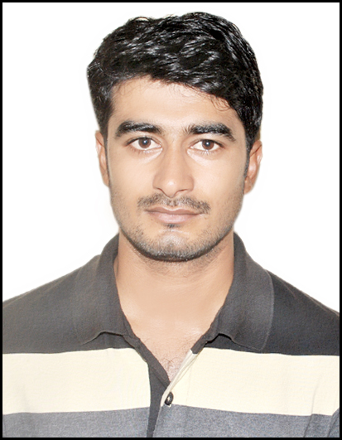
- Father’s Name:- Mr. Bangali Singh
- Mother’s Name:- Mrs. Shyamvati Devi
- Date of Birth :- 01/01/1990
- Qualification :- M.P.Ed./UGC NET/Ph.D.

- Mobile No. :- 9410088001
- E-mail ID :- mr.gaganchaudhary@gmail.com
- Permanent Address:- VPO- Baramai, Distt.- Hathras, 281302, U.P.
- Present Address:- BK nagar (in front of KV),Kasrawad road, Khargone
- Post :- Sports Officer
- Date of Joining :- 16/12/2019
- Date of Regularization:-
- Date of Confirmation:-
- Date of Probation :-
- Orientation course :- Date Name of ASC/University
1. ………………………………… …………………………………………………………………..
- Refresher course :- Date Name of ASC/University
1. ………………………………… …………………………………………………………………..
- Senior Grade :- …………………………………………………………………..
- Selection Grade :- …………………………………………………………………..
- Date of Promotion :- …………………………………………………………………..
- Number of Attended Workshops :- 03..
- Number of Attended Seminars/conferences :-1.International:-01
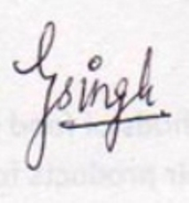
2.National:-06
- Number of Published papers in journal :- 04
Signature:-

